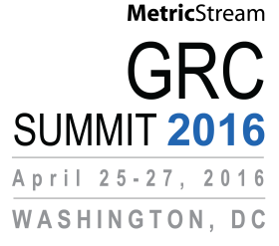

**US $1,249**

**US $1,999**

Early Bird Pass

Regular Summit Pass

I have read and agree to the registration policies published on <http://www.grc-summit.com/us/2016/registrationpolicies.htm>

Total Number of Attendees   
Discount Code

Total Amount

Expiration Date   
CVV Number

Credit Card (circle /highlight card type): Visa/MasterCard/American Express  
Credit Card Number   
Card Holder Name   
Billing Address   
Bill My Organization Purchase Order #  
Pay by Check Checks Payable to MetricStream, Inc.

SELECT PAYMENT METHOD

Signature

[**www.GRC-Summit.com**](http://www.GRC-Summit.com)

1   
2   
3   
4

**REGISTRATION FORM**

Organization   
Phone   
City & State   
Country

Name   
Title   
Email   
Address   
Zip Code

ADDITIONAL ATTENDEES

PAYMENT DETAILS

**US $1,250.00**

**US $1,000.00**

**Early Bird**

**REGISTRATION FEE**

# Name Title Email Phone

CONTACT INFORMATION

Please complete this form and email a scanned copy to   
[grc-summit@metricstream.com](mailto:grc-summit@metricstream.com) to register for MetricStream GRC Summit 2016. For more information, please visit [www.GRC-Summit.com](http://www.GRC-Summit.com).